MarketinGuru

Data-Driven Marketing Intelligence Platform

**A**pplication **R**equirements **D**ocument

**Evyatar Kopans**

**Yuval Goldstein**

**Peleg Ben-Barak**

**Ron Franco**

November 26, 2024

Version 1.1

Table of Content

**1. Introduction 6**

1.1 Goals 6

1.2 The problem domain: 7

1. Information gathering: 7

2. Make correct analysis of the data: 8

3. Presenting the information in a coherent and understandable way 8

1.3 Context: 9

1.4 Vision: 11

1.5 Stakeholders: 12

1.6 Software context: 13

Input: 13

Processing: 14

Output: 15

**2. Usage Scenarios 16**

2.1 User Profiles — The Actors 16

2.1.1 Marketing Staff 16

2.1.2 Customers (External Actors) 16

2.1.3 Aggregation System 16

2.2 Use-Cases Diagram 17

2.2.1 UC1 - Generate and Edit Landing Pages 18

2.2.2 UC2 - Transfer and Aggregate UTM Data 22

2.2.3 UC3 - Transfer and Aggregate Data from Social Networks (LinkedIn, Google Analytics, Meta) 23

2.2.4 UC4 - Cross-Source Data Aggregation and Optimization 24

2.2.5 UC5 - Campaign Analysis - (cost per click/lead) 26

2.2.6 UC6 - ICP analysis (cost per MQL/SQL/CUSTOMER) 28

2.2.7 UC7 - ICP and Campaign Analysis Visualization 30

2.2.8 UC8 - Publish Campaigns Simultaneously 31

2.3 Special Usage Considerations 33

2.3.1 System implementation 33

2.3.3 Compliance Regulations 34

GDPR (General Data Protection Regulation) 34

CCPA/CPRA (California Consumer Privacy Act) 34

PECR (Privacy and Electronic Communications Regulations) 34

CAN-SPAM Act (USA) 35

Data Security and Confidentiality 35

2.3.4 Additional Considerations 35

Personalization vs. Privacy 35

Third-Party Integrations 35

Children’s Privacy 35

2.3.5 Cookie Management and Privacy by Design 36

2.3.6 Compliance Monitoring and Reporting 36

**3. Functional Requirements 37**

3.1 Cross-Platform Campaign Posting 37

[3.1.1 Campaign Publishing  
The system shall enable the users select social platforms to publish and manage campaigns with a single query. The system will provide a predefined form to fill which answers all mandatory fields in the different selected platforms. 37](#_heading=h.8qr30fj7krfa)

3.1.2 Campaign Scheduling 37

3.2 Data collection cleaning and retrieval. 37

3.2.1 Data transport and backup 37

3.2.2 Data Transformation 38

3.2.3 Data crossing 38

3.3 Predictions 38

3.4 Data Privacy and Security 39

3.4.1 Access Control (by google auth) 39

3.5 Landing Page Generation 39

3.6 Campaign Performance Tracking 39

3.7 Customer Profiling 39

3.8 Campaign Visualization 40

3.8.1 Marketing Funnel Visualization 40

3.8.2 Customer Insights Dashboard 40

3.8.3 the system will present global data such as: 41

3.8.4 Dashboard Customization 41

3.8.5 Data Export Options 41

**4. Non-Functional Requirements 41**

4.1 Implementation constraints 41

4.1.1 Speed (Real-Time Updates) 41

4.1.2 Capacity 41

4.1.3 Security 42

4.1.4 Portability 42

4.1.5 Usability 42

4.1.6 Availability 42

4.1.7 compliance monitoring 42

4.1.8 compliance with social media post conventions and constraints 42

4.2 Platform constraints 43

4.3 Error Logs and Retries 43

4.4 special restriction & limitations 43

**5. Risk Assessment & Plan for the POC 44**

5.1 Overview 44

Risk Assessment Table 46

plan for P.O.C implementation: 47

Risk 1: Integration for Cross-Platform Posting 47

Risk 2: Data Retrieval Challenges - expand further for each API connection 48

Risk 3: ICP detection and Visualization 48

Risk 4: Data Privacy and Security 50

Risk 5: Complexity of Working with BigQuery 50

Risk 6: Implementing a NoCode Solution for Landing Pages 51

Risk 7: Challenges in Identifying ICP 51

**Appendices 55**

1.1. Glossary 55

# 1. Introduction

## 1.1 Goals

*"Without data, you're just another person with an opinion." – William E. Deming.*

The concept of an Ideal Customer Profile (ICP) has been a cornerstone of marketing for decades. Basically, it's the answer to the question *"Who will buy my product/ services?".* Back then, before the emergence of data-driven methods and super computers, traditional approaches often relied on intuition and broad generalizations, leaving too much to chance. In today’s competitive world however, where sales are as essential to companies as air is to life, data-driven methods have revolutionized marketing, transforming it into a precise, measurable, and highly impactful discipline. These advances allow businesses not only to understand their customers better but also to craft strategies that resonate deeply and deliver tangible results.

Our project, *MarketinGuru*, harnesses this revolution. It is more than just a platform; it is our gateway to intelligent, data-driven marketing. By combining advanced algorithms and tools with comprehensive data analysis, *MarketinGuru* will enable us to redefine our company’s approach to marketing, provide an unprecedented ability to identify and adapt to our Ideal Customer Profile with precision, ensuring that every marketing effort is purposeful and effective.

Because at the end of the day, every company is a marketing company. Whether you sell software, shoes, or services, success depends on how well you understand your customers and meet their needs. With *MarketinGuru*, we’re not just keeping up with the competition-we’re setting the standard. This platform empowers us to connect meaningfully with our customers, adapt to market changes, and drive sustained growth. It’s not just about marketing; it’s about transforming how we think, operate, and succeed in the modern world.

## 1.2 The problem domain:

In contemporary marketing teams within companies, there is often difficulty in targeting the right clients for a product and determining which actions will attract or repel the ideal customer. While a trial-and-error approach works for some companies on a certain scale, effective targeting requires analytical tools that support informed marketing and development decisions. These decisions, in turn, drive company growth and increase revenue.

There are three main challenges in marketing intelligence analysis:

### Information gathering:

The first challenge is identifying reliable sources for marketing intelligence, distinguishing important data from redundant information, and categorizing it effectively-tasks that are not easy to accomplish. Making informed marketing decisions requires massive amounts of data, but obtaining and organizing this data is complex. Common sources include social media, market trend analyses, and analyses of active user behavior, among others. Finally, organizing this data in a concise and analyzable manner presents another challenge, as it's impossible to consider all collected data in every marketing decision.

### Make correct analysis of the data:

Once data is collected, using it wisely to make predictions is essential but challenging. Assessing whether these predictions have been “optimal” (i.e., the most productive) can sometimes be an unanswerable question. Additionally, deriving the correct conclusions from the data is not a trivial task. Also finding linked between different data pieces and connecting them to derive conclusions is a task which is not so easy to answer.

### Presenting the information in a coherent and understandable way

Converting large datasets into a human-readable format can be challenging and highly subjective; what may be clear to one person could be incomprehensible to another.

The goal of our project is to provide marketing professionals with a framework that automates parts of the analysis process. This includes auto-collection of relevant information from various sources, automated analysis of this data, and presenting the analysis results in a readable and understandable way. Of course, some of the challenges mentioned above will shift from problems faced by the marketing professional to problems we, as the developers of the product, will need to solve.

## 1.3 Context:

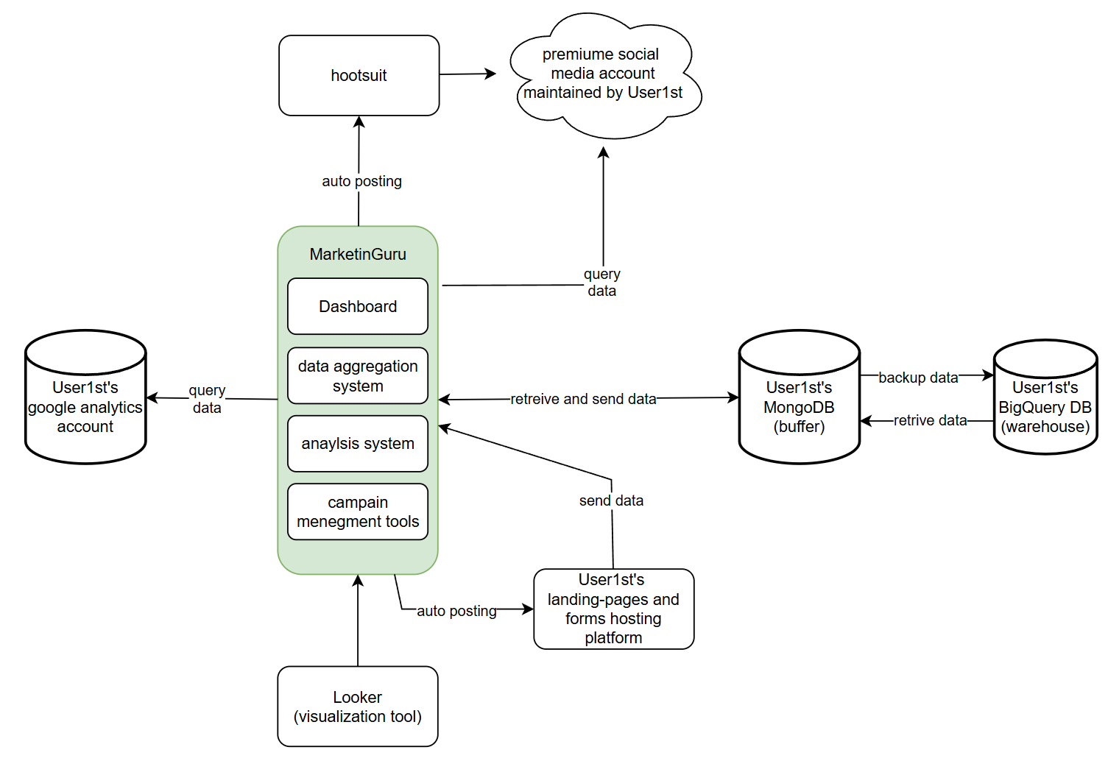

* **BigQuary**: is a Google product to which User1st subscribes. It is a data warehouse that provides fast querying capabilities and a platform for data analytics. User1st sends a large amount of relevant information from various components (described in the diagram) to this database. Our system will integrate with BigQuery to retrieve the data necessary for our operations and also to store information. Another feature this external system provides for us is backup for information residing in the different platforms (google analytics, cookies and so on), so if and when there will be some change of policy with those platforms, the recorded data gathered so far would be within User1st reach. A downside of this platform is the cost of usage, which we will solve using a MongoDB database.
* **MongoDB**: is the database which which User1st will allocate for the perpious of this project. this data base, aside from managing general information about the project, will be used a buffer between the Data aggregation system and BigQuery for the purposes of reducing cost of usage in BigQuery as mentioned above.
* **Looker:** looker is a business intelligence tool from Google Cloud that helps organizations explore, analyze, and visualize data for informed decision-making. a key feature of looker is it’s powerful and interactive visualizations tool, our system would integrate with looker to provide visualization on the data collected and stored in BigQuery
* **Google Analytics**: User1st also subscribes to Google Analytics, another Google product. This service provides insights into traffic analysis, audience demographics, acquisition tracking, behavior analysis, and more. Information from Google Analytics is sent to BigQuery, which our system then retrieves and paints a bigger picture with.
* **Landing pages and forms**: User1st maintains landing pages and forms for user acquisition and registration. Information from these pages is also sent to BigQuery for later retrieval. Our system will allow new landing pages to be posted with customized design and text at the click of a button.
* **Hootsuit**: User1st is planning to buy an account in Hootsuit which is a 3rd party platform for campaign management (we will use it for auto-posting campaigns in different social media platforms).
* **MarketinGuru Dashboard**: will give visualization for data collected and stored in bigQuery, this platform will rely heavily on a looker as a third party platform.
* **MarketinGuru aggregation system**: will query from time to time the different platform and store them in the buffer/use it for analysis.
* **MarketinGuru analysis system**: will use the collected data to make analysis and and recommendation for the marketing stag
* **MarketinGuru campaign management tools**: the main feature this system provides is auto posting in social media using hootsuits and giving a landing page editing system

**NOTE:** marketing guru functionalities and abilities are further explained ahead.

## 1.4 Vision:

The main goal of our project is to provide a marketing analysis framework for the User1st marketing team that is personally tailored to their needs. Success will be achieved if our platform identifies the ideal customer profile (ICP) for User1st and simplifies the day-to-day work of marketing personnel.

**The tool will offer several key functionalities, including:**

* **Automatic Data Collection**: Gather data from multiple sources, such as social media campaigns, frequently searched keywords on search engines, and demographics of active and potential users (using cookies and google analytics to better understand the user which we target).
* **Automated Data Analysis**: Analyze the collected data to identify the ICP and detect trends in the dynamic market.
* **Customizable Data Presentation**: Display data in customizable charts and diagrams for the convenience of the marketing team.

The main challenges we will address include integrating with User1st's existing data collection methods (such as Google Analytics, User1st landing pages, and forms) and enhancing these sources. We will also focus on filtering essential information from irrelevant data, developing a suitable dashboard for the marketing team, and integrating with User1st’s landing pages hosting domain to enable automation tools.

**Once the core system is implemented and major obstacles are addressed, we envision expanding the system as follows:**

* **AI-Powered Market Prediction**: Utilize state-of-the-art AI techniques to forecast market shifts and evolving ICPs. the system will not be expected to train a model based on the amount of data the company is presented with, instead, the system will use few-shot learning or fine tuning techniques.
* **ROI Analysis**: Analyze campaign return on investment (ROI) to detect when a campaign has reached the point of diminishing returns.
* **User Action Analysis**: Examine actions taken by users on the User1st site, identifying behaviors that may deter purchases

## 1.5 Stakeholders:

* **User1st’s Marketing Team (Informed Customers):**

The marketing team will be the primary user of our system. Requirements are primarily elicited from them, and they provide feedback on whether a feature is redundant, important, or highly useful.

* **User1st’s R&D Team (Technology Experts):**

User1st's research and development team will help us determine which customer-suggested requirements are feasible given the company’s resources, which would be too costly to maintain, and what can be achieved within the project's timeframe. The R&D team will also assist us in seamlessly integrating our system with the company’s existing infrastructure.

* **User1st’s Legal/ Compliance Department (Law Experts):**

The legal department will help us ensure that proposed features and requirements are lawful and will provide guidance on adjustments if any elements are non-compliant.

## 1.6 Software context:

### Input:

As mentioned, the primary input for our system is user data collected from various sources. The following list provides a guideline for the types of data our platform will gather:

* **From google analytics (general an non personalized information):**
* **Age, Gender, Location**: can help with understanding the ICP
* **Device and Browser Type**: devices type (mobile, desktop) and browsers (Chrome, Safari, etc.) that users prefer helps in optimizing website design and functionality.
* **Referral Sources**: where users come from (direct, search engines, social media, other websites). can help in understanding which channels drive the most traffic.
* **Page Views and Session Duration**: helping assess content effectiveness.
* **Bounce Rate**: Indicates if users leave immediately after visiting a page, which can reveal issues with relevance and user experience.
* **Conversion Rate**: Measures the percentage of users who complete specific goals, such as signing up, purchasing, or subscribing.
* **Click Path Analysis**: Tracks the sequence of pages visited by users, helping identify common paths or drop-off points.
* **Frequency and Recency**: Shows how often and how recently users return, helping gauge brand loyalty.
* **Interest Categories**: Using Google’s affinity data, marketers can understand users' broader interests (e.g., travel, fitness), which helps in targeted ad placements and content strategy.
* **From social media(general an non personalized information):**
* **Demographics**: understanding the potential user age, gender, location, job titles, income, education level, behaviours, interests, and values. This helps in refining the ICP.
* **Likes, Comments, Shares, and Reactions**: helps in understanding the ICP and the effectiveness of a campaign
* **Click-Through Rate**: The percentage of people who click on your ad or post out of the total number who saw it. Can gauge campaign effectiveness
* **Ad Placement Insights**: how ads performed across different placements (e.g., feed, stories, sidebar), helping optimize campaign decisions.
* **Behavioral Data**: Insights into how users interact with your content (e.g., time spent, clicks, engagement with specific parts of your post or video) help optimize future campaigns.
* **From landing pages and forms:**

For potential clients who have user1st cookies who reached the user1st landing page, the system will collect the cookie’s path and data to obtain as much information as possible as to where the client came from in the web, what other sites he visited before and so on.

**Another form of input is the auto-posting tool which is pretty straight forward:**

* **Auto-posting on social media**: takes text of the post, an optional image, and a list of social networks to which we want to post.
* **Auto-posting landing pages**: takes the customizable element of a landing page (text, color, logo, images and so on) and generates a new landing page with those properties.

### Processing:

the processing the system will do is mostly inference based on different data, for example:

* understand better the traffic that comes into your site, as mentioned google analytics for instance gives very general information, but intertwined with cookies and different piece of information we can deduce more information about the clientele.
* make calculation of campaign cost and rates between cost and profit.
* The most promising candidate for the machine learning algorithm for ICP prediction is decision tree, which will be used to classify the different users as relevant user/non relevant user.
* making queries on the data to filter or compare different collected data.

### Output:

There are four main output channels:

* **Dashboard Display**: Collected data is presented in the software UI (dashboard) in a customizable way, allowing each user to select specific charts and query the system accordingly.
* **Direct conclusion from the data:** the system will have a couple of schemas of tying data together and deriving more information and relation between information.
* **Marketing Suggestions(as time allows)**: Based on collected data, and use of third party libraries the system provides recommendations on a set of predefined subjects regarding the target audience, campaign success, and more.

# 2. Usage Scenarios

## User Profiles — The Actors

### 2.1.1 Marketing Staff

* **Description**: The primary actors of MarketinGuru. These individuals are responsible for creating and managing marketing campaigns, generating landing pages, and act upon the customer data displayed in the dashboard.
* **Role**: They interact with the Landing Page System Analytics Dashboard and Post campaigns and posts to execute marketing strategies efficiently.
* **Key Characteristics**: Tech-savvy individuals familiar with basic digital marketing tools and concepts. They rely on the system’s no-code functionality for ease of use.

### 2.1.2 Customers (External Actors)

* **Description**: External users that interact passively (and unknowingly) with marketiGuru. Their interactions with our platform are landing pages' visits and published campaigns they clicked/filled/found interesting. These customers' data is then captured by MarketinGuru and serves as the backbone of our project.
* **Role**: Their data is collected, analyzed, and used to identify the Ideal Customer Profile (ICP).
* **Key Characteristics**: Non-technical users who interact with campaigns and landing pages through various digital platforms like LinkedIn, Google, and Meta.

### Aggregation System

* **Description**: A sub-system within MarketinGuru that operates independently to collect and transfer data.
* **Role**: Functions as a bridge between MongoDB (cookies data) and BigQuery, while also retrieving data from external APIs (Google Analytics, Meta, LinkedIn).
* **Why It’s an Actor**: Although it is part of the internal architecture, its role as a data exchange interface qualifies it as an external actor for the purpose of usage scenarios. It triggers data exchanges without direct input from other system components.

## 2.2 Use-Cases Diagram

### 

### 2.2.1 UC1 - Generate and Edit Landing Pages

**Primary Actor**: Marketing Staff

**Description**: The Marketing Staff member accesses the Landing Page System to create or update landing pages using a noCode solution architecture.

**Preconditions**:

* + The user has a proper Wi-Fi connection.
  + User1st's server is up and running.
  + For reading/editing a Landing Page: Must exist at least 1 Landing Page.
  + MongoDB and its replica are operational.

**Main Success Scenario**:

* + The user clicks the “Landing Page System” button on the main page.
  + The system redirects them to the Landing Page interface.
  + The user selects “Create”, “Update” or "Read".

**“create” scenario:**

* + When clicking "Create": the users are presented with a blank template consisting of predefined sections to edit.

**“update” scenario:**

* + - The platform checks for existing Landing Pages
    - If any LP were found, the users are presented with the list of all existing landing pages available for edit.
    - After the user chooses a page, the selected page is opened in edit mode, allowing inline text editing and image replacement.
    - The system saves the updated landing page and syncs the changes across MongoDB replicas.

**“read” scenario:**

* + - the platform checks for existing Landing Pages
    - If any LP were found, the users are presented with the list of all existing landing pages to browse.
    - After the user chooses a page, the selected page is opened in read mode, not allowing changes.

**Postconditions**:

* + If Created/Updated:
    - The new Landing page is uploaded to the internet.
    - UTM parameters are properly embedded in the new landing page URL.

**Alternative Flows and Exceptions:**

If no landing pages exist when "Update" or "Read" is clicked:

* The system notifies the user that no landing pages are available and provides an option to create a new landing page instead.

If MongoDB connection is lost during editing:

* The system notifies the user of a temporary save error, allowing the user to retry saving or store the changes locally until the connection is restored.

If an image upload fails during editing:

* The system alerts the user that the image could not be uploaded and prompts them to try again or select a different image.

If the user tries to create/edit but the template fails to load:

* The system displays an error message and offers to reload the template or restart the process.

If the server becomes unavailable:

* The system notifies the user of a connection issue and prompts it to retry the operation later.

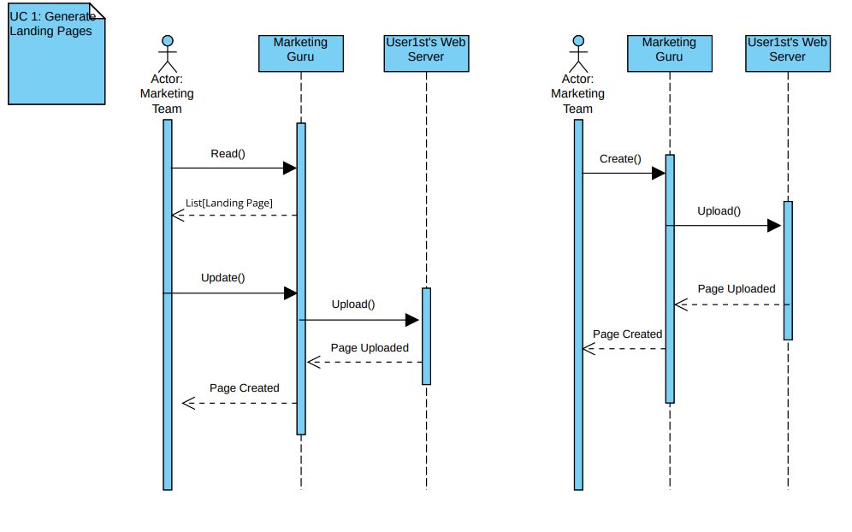

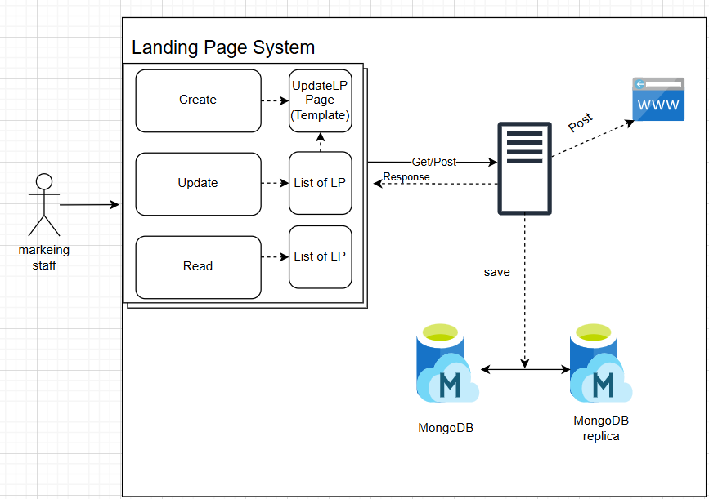

### 2.2.2 UC2 - Transfer and Aggregate UTM Data

**Primary Actor:** Aggregation System - UTMs

**Description:** The system automatically retrieves and aggregates UTM data from landing pages to MongoDB for optimized processing before uploading to BigQuery.

**Preconditions:**

* MongoDB is operational and contains necessary cookie and UTM-related data.
* UTM parameters are properly embedded in landing page URLs.
* BigQuery is operational and accessible.

**Main Success Scenario:**

1. At a scheduled interval, the system pulls cookie and UTM data from landing pages via MongoDB.
2. The collected data is cleaned and formatted to align with BigQuery's schema requirements.
3. The system consolidates similar UTMs to optimize the data volume before upload.
4. The processed data is uploaded to BigQuery.
5. The system logs the success or failure of the upload action.

**Postconditions:**

* BigQuery contains consolidated UTM data for analysis.

**Alternative Flows and Exceptions:**

* If MongoDB connection fails: The system retries up to three times. Persistent failure is logged, and an alert is sent to administrators.
* If BigQuery upload fails: Data is temporarily stored locally, and administrators are alerted for manual resolution.

### 2.2.3 UC3 - Transfer and Aggregate Data from Social Networks (LinkedIn, Google Analytics, Meta)

**Primary Actor:** Aggregation System - Social Networks

**Description:** The Aggregation System retrieves and aggregates data from LinkedIn, Google Analytics, and Meta at scheduled intervals. Said data is collected from both campaign assessments and user presence in the mentioned networks.

**Preconditions:**

* API keys for LinkedIn, Google Analytics, and Meta are configured and valid.
* MongoDB is operational and accessible for storing intermediate data.
* BigQuery is accessible for final data storage.

**Main Success Scenario:**

1. At a scheduled interval, the system retrieves data from LinkedIn, Google Analytics, and Meta using their APIs.
2. The retrieved data is cleaned and aggregated in MongoDB.
3. The system formats the aggregated data to meet BigQuery’s schema requirements.
4. The cleaned and formatted data is uploaded to BigQuery.
5. The system logs success or failure for each platform’s data transfer action.

**Postconditions:**

* BigQuery contains aggregated and formatted data from social networks for analysis.

**Alternative Flows and Exceptions:**

* If an API call to any social network fails: The system retries the request up to three times. If it continues to fail, the issue is logged, and an alert is sent to the administrator.
* If BigQuery upload fails: Data is temporarily stored in MongoDB or a local backup, and administrators are alerted.

### 2.2.4 UC4 - Cross-Source Data Aggregation and Optimization

**Primary Actor:** Aggregation System - Cross Data

**Description:** The system consolidates data from both UTM sources and social networks *(see: use-cases 2 & 3)*, ensuring optimized upload to BigQuery and Data crossing for each user from Landing page visits (stored cookies), Campaign analysis and Social Media presence.

**Preconditions:**

* MongoDB contains pre-processed data from both UTMs and social networks.
* BigQuery is operational and accessible.
* Data schemas for cross-source integration are predefined.

**Main Success Scenario:**

1. The system consolidates data from MongoDB for both UTM and social network sources.
2. Duplicate or redundant entries are removed to optimize storage.
3. The system links same-user data from different sources to fully depict user attributes, behaviour and additional information related to ICP detection from social media (like accessibility related interests found in the user’s linkedIn page).
4. The consolidated data is cleaned and formatted to match BigQuery’s schema.
5. The processed data is uploaded to BigQuery.
6. Logs for success or failure are maintained for cross-source data uploads.

**Postconditions:**

* BigQuery contains optimized and consolidated data from UTMs and social networks.

**Alternative Flows and Exceptions:**

* If data integration fails due to schema mismatch: The system retries formatting with predefined rules or logs the error for administrator intervention.
* If MongoDB or BigQuery is unavailable: Temporary storage is used until the system reconnects.

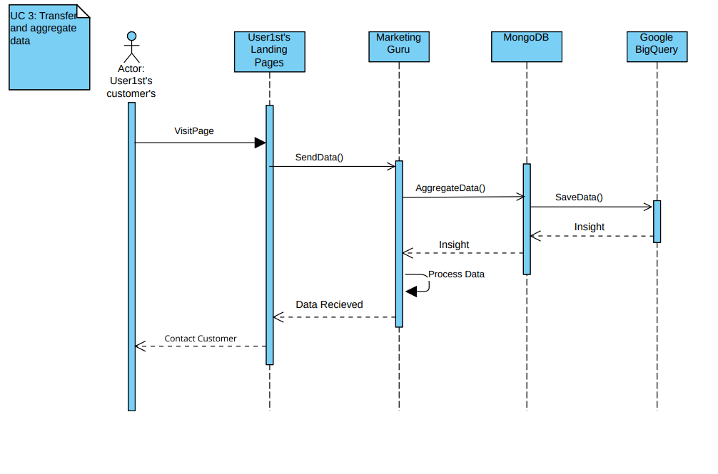

### 2.2.5 UC5 - Campaign Analysis - (cost per click/lead)

**Primary Actor:** Marketing Staff

**Description:** The system will analyze campaign performance and assess campaign ROI based on metrics such as Cost per Click (CPC) and Cost per Lead (CPL). This ability allows the marketing staff to compare campaigns from different platforms.

**Preconditions:**

* + The user has a proper Wi-Fi connection.
  + User1st's server is up and running.
  + Campaigns have been published to different platforms
  + BigQuery contains processed data for analysis.

**Main Success Scenario:**

* + The system retrieves data from BigQuery.
  + The system performs comparison between published campaigns: campaign cost, amount of clicks, amount of CTA (call to action - a user leaving contact information to receive a demo and a sales call), average cost per click, average cost per lead (CTA users) and other campaign performance metrics *TBD*.

**Postconditions:**

* + Marketing strategies are refined based on data-driven insights.
  + Different platforms for campaigns are now empirically measured !

**Alternative Flows and Exceptions:**

* + If BigQuery connection fails/ Looker visualizations fail to load: The system displays an error message indicating that data cannot be retrieved.
  + if no campaigns have been published or if the data hasn't been uploaded to bigQuery a “no data for show” message is displayed.

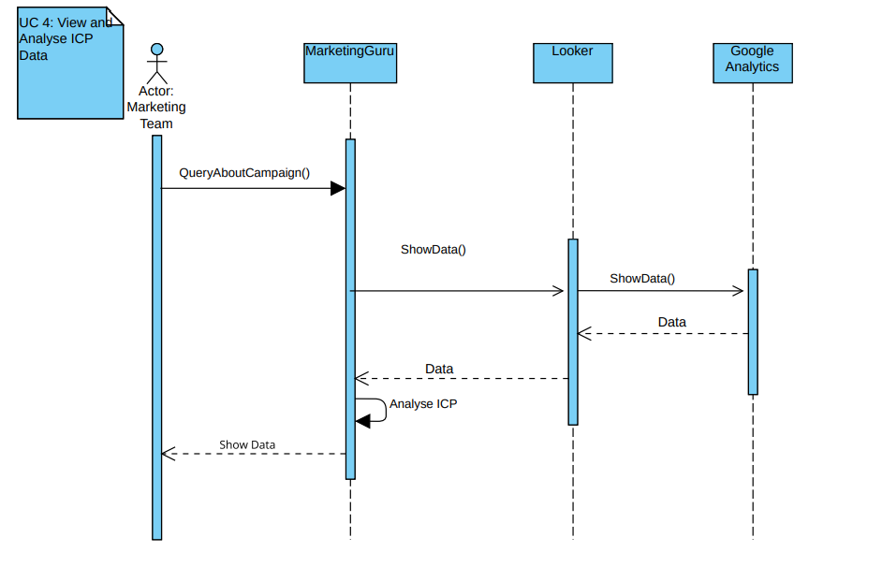

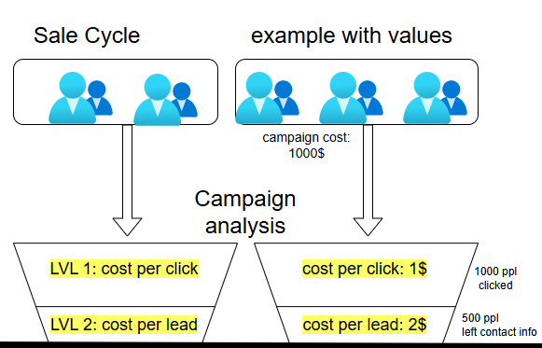

### 2.2.6 UC6 - ICP analysis (cost per MQL/SQL/CUSTOMER)

**Primary Actor:** Marketing Staff

**Description:** The system will analyze different customer attributes in order to get a better understanding of what defines an average customer and what our customers have in common, so that they could focus their sales effort on higher-probability-for-purchase customers.

**Preconditions:**

* + Existing customer analysis has been made and “*good-customer” heuristics* were defined.
  + The user has a proper Wi-Fi connection.
  + User1st's server is up and running.
  + all available customer attributes and information has been uploaded to bigQuery.
  + BigQuery and the company server are up and running.

**Main Success Scenario:**

* + The system retrieves data from BigQuery for each campaign and all campaigns are set for analysis.
  + The user selects a campaign from the list.
  + The system uses Looker to generate and display 5 user categories for the selected campaign. for each :

1. ***Cost per Click (CPC)/ Cost per Lead (CPL)*** - when one of these categories is selected, the user is directed to the analysis from the previous use-case *(see: use-case 5)* *“Campaign Analysis”*
2. ***Marketing Qualified Lead (MQL)*** - when this category is selected a list of all the users who clicked the campaign, and all their relevant information is displayed. Each user in this category will have an attribute of “move to SQL” - meaning a marketing agent made contact with the user and a sales process was established. Additionally, the system will display the average cost per MQL and all defined heuristics that were executed in order to filter the *CPL users,* and allow the marketing staff to disable/activate different heuristics in order to check their efficiency and accuracy.
3. ***Sales Qualified Lead (SQL)*** - when this category is selected a list of all the MQL’s that are currently in a sales process will be displayed.
4. ***new Customers -*** when this category is selected, a list of all the new customers, brought through this campaign, and their respective cost/profit ratio and amount is displayed.
   * Additional campaign performance metrics and customers’ heuristics *TBD*.

**Postconditions:**

* + different lead categories are properly differentiated.
  + sales efforts are distributed better.
  + the marketing staff has a better understanding of customer attributes and needs.
  + Marketing strategies are refined based on data-driven insights.
  + Different heuristics for customers are now empirically measured !

**Alternative Flows and Exceptions:**

* + If BigQuery connection fails/ Looker visualizations fail to load: The system displays an error message indicating that data cannot be retrieved.
  + if no campaigns have been published or if the data hasn't been uploaded to bigQuery a “no data for show” message is displayed.

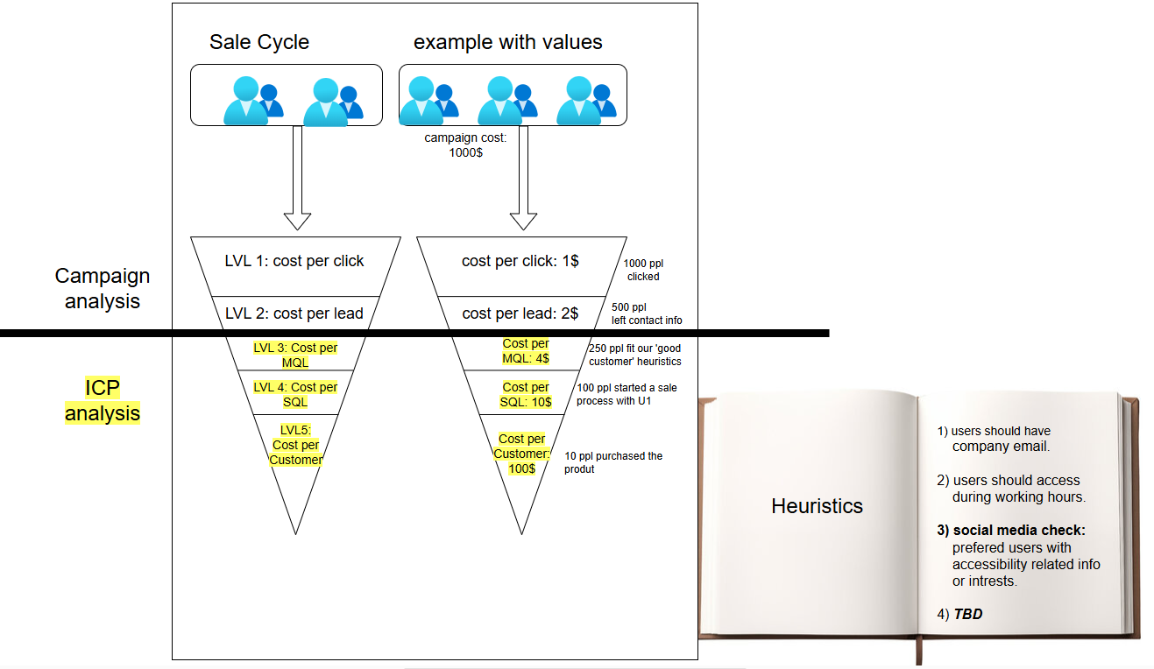

### 2.2.7 UC7 - ICP and Campaign Analysis Visualization

**Primary Actor:** Marketing Staff

**Description:** The Marketing Staff member accesses the Dashboard to analyze and view insights about campaign performance, assessments ,ICP insights, heuristics check and MQLs ready for a sales call. Visualizing this data allows the marketing staff to better view and analyze different campaigns and customer assessments in order to efficiently distribute sales efforts between potential customers.

**Preconditions:**

* + The user has a proper Wi-Fi connection.
  + User1st's server is up and running.
  + Campaigns have been published to different platforms
  + BigQuery contains processed data for analysis.

**Main Success Scenario:**

* + The user clicks the “Dashboard” button on the main page.
  + The system retrieves data from BigQuery.
  + The system uses Looker to generate and display interactive comparison between published campaigns: campaign cost, amount of clicks, amount of CTA (call to action - a user leaving contact information to receive a demo and a sales call), average cost per click, average cost per lead (CTA user) and other campaign performance metrics *TBD*.

**Postconditions:**

* + All data from previous use-cases *(see: use-cases 5 & 6)* is displayed as described previously.
  + Marketing strategies are refined based on data-driven insights.
  + Campaign and ICP analysis are now visualized in marketinGuru’s Dashboard, allowing marketing staff to test different ICP heuristics and campaign performance in an interactive way.

**Alternative Flows and Exceptions:**

* + If BigQuery connection fails/ Looker visualizations fail to load: The system displays an error message indicating that data cannot be retrieved.
  + if no campaigns have been published or if the data hasn't been uploaded to bigQuery a “no data for show” message is displayed.

### 2.2.8 UC8 - Publish Campaigns Simultaneously

**Primary Actor:** Marketing Staff

**Description:** The Marketing Staff member accesses the Campaign Posting System to draft and publish marketing campaigns across multiple platforms.

**Preconditions:**

* + The user has a proper Wi-Fi connection.
  + User1st's server is up and running.
  + API keys for LinkedIn, Meta, and Google are properly configured.

**Main Success Scenario:**

* + The user clicks the “Campaign System” button on the main page.
  + The system redirects them to the Campaign Posting System interface.
  + The user drafts campaign content and selects target platforms (LinkedIn, Meta, and/or Google).
  + The system validates campaign compatibility with each platform.
  + The user confirms the draft, and the system makes API calls to publish the campaign on the selected platforms.
  + The system logs the success or failure of each publishing action.

**Postconditions:**

* + Campaigns are successfully published on the selected platforms.

**Alternative Flows and Exceptions:**

**If validation fails for one or more platforms:** The system notifies the user of the specific issue, allowing them to modify and revalidate the campaign.  
**If API call fails for a specific platform:** The system retries the publishing action up to three times. If it still fails, the user is notified, and the issue is logged for troubleshooting.  
I**f the user has no internet connection:** The system displays a connection error and prevents further steps until connectivity is restored.

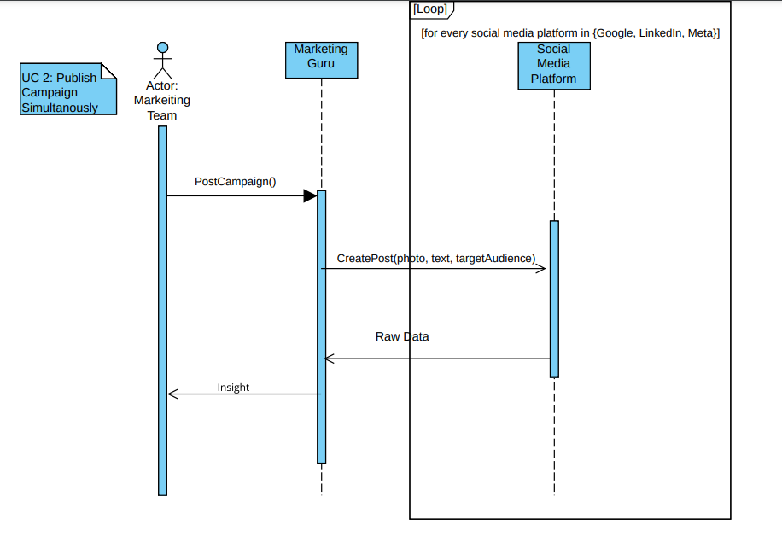

## 2.3 Special Usage Considerations

### 2.3.1 System implementation

* **System Scalability**:  
  The system must handle a high volume of data from multiple sources without performance degradation, especially during peak campaign periods.
* **Error Handling**:
  + Robust logging mechanisms for the Aggregation System to handle API failures or network issues.
  + Graceful fallbacks for scenarios where external APIs are temporarily unavailable.
* **Testing Scenarios**:  
  Each subsystem must be tested individually for:
  + CRU~~D~~ operations (Landing Page System).
  + API connectivity (Campaign Posting System).
  + Data consistency and synchronization (Aggregation System).
  + Accuracy of insights and analytics (ICP Dashboard).

2.3.2 Data Privacy Compliance overview

The marketing system adheres to global data protection and privacy laws to ensure responsible and legal handling of user data. Compliance is achieved through strict adherence to regulations such as GDPR, CCPA/CPRA, PECR, CAN-SPAM, and other regional laws. This ensures user trust, protects sensitive information, and avoids legal penalties.

### 2.3.3 Compliance Regulations

#### GDPR (General Data Protection Regulation)

* **Scope:** Applies to users in the European Union.
* **Key Compliance Actions:**
  + **Consent:** Explicit consent is obtained before collecting personal data such as email addresses or cookies. This is managed through cookie banners and opt-in forms.
  + **Transparency:** Users are informed about data collection purposes via privacy policies and clear notices.
  + **Data Minimization:** Only collect data necessary for specific marketing purposes.
  + **User Rights:** Provide mechanisms for users to access, modify, or request deletion of their data.
  + **Data Retention:** Store data only for as long as necessary for its intended purpose and delete it after its lifecycle ends.

#### CCPA/CPRA (California Consumer Privacy Act)

* **Scope:** Applies to users in California.
* **Key Compliance Actions:**
  + **Opt-Out Options:** Users can opt out of the sale or sharing of their personal data through a simple interface.
  + **User Requests:** Facilitate requests to know, delete, or opt out of data processing activities.
  + **Privacy Notices:** Clearly explain data collection, usage, and sharing practices in plain language.

#### PECR (Privacy and Electronic Communications Regulations)

* **Scope:** Governs electronic communications and cookie use in the UK.
* **Key Compliance Actions:**
  + **Cookie Consent:** Obtain user consent for all non-essential cookies.
  + **Marketing Communications:** Send marketing emails or SMS messages only to users who have explicitly opted in. Soft opt-in is applied for existing customers.

#### CAN-SPAM Act (USA)

* **Scope:** Covers commercial email communications in the United States.
* **Key Compliance Actions:**
  + **Opt-Out Mechanism:** Include a simple and clear way for users to unsubscribe from marketing emails.
  + **Accurate Communication:** Avoid misleading or deceptive subject lines or sender names.
  + **Business Details:** Ensure emails include the sender's physical address.

#### Data Security and Confidentiality

* **Encryption:** All data transmission and storage are encrypted to prevent unauthorized access.
* **Access Control:** Sensitive data is segmented and access is restricted to authorized personnel.
* **Breach Notifications:** Implement processes to promptly notify authorities and affected users in case of a data breach.

### 2.3.4 Additional Considerations

#### Personalization vs. Privacy

* **Anonymized Data:** Personal data is anonymized wherever possible to maintain privacy while enabling targeted marketing.
* **Purpose Limitation:** Ensure all marketing activities are compliant with the principles of data minimization and necessity.

#### Third-Party Integrations

* Ensure all third-party vendors (e.g., analytics or ad services) comply with relevant data privacy regulations and adhere to strict standards for handling user data.

### 2.3.5 Cookie Management and Privacy by Design

Consent Management

* Users are presented with a cookie banner for explicit consent. The banner includes:
  + Types of cookies being collected (e.g., necessary, functional, marketing).
  + Purpose of each cookie category.
  + An option to manage or withdraw consent at any time.

Secure Consent Storage

* Consent records are securely stored in encrypted databases to ensure traceability and compliance with GDPR/CCPA audits.

Privacy by Design

* **Default Settings:** The system is designed with privacy as the default setting, collecting minimal data and ensuring it is stored securely.
* **Continuous Monitoring:** Regular audits and monitoring processes ensure ongoing compliance with data privacy regulations.

### 2.3.6 Compliance Monitoring and Reporting

* **Logs and Reports:** Maintain detailed logs of data collection, user consent, and data processing activities.
* **Audit Readiness:** Ensure all processes align with regulatory standards for seamless audit compliance.

# 3. Functional Requirements

## Cross-Platform Campaign Posting

### Campaign Publishing

### The system shall enable the users select social platforms to publish and manage campaigns with a single query. The system will provide a predefined form to fill which answers all mandatory fields in the different selected platforms.

### Campaign Scheduling

The system shall enable users to schedule campaigns for future publishing by filling the query for auto publishing and setting specific time for publishing.

## Data collection cleaning and retrieval.

### Data transport and backup

* + - 1. The system will collect cookie data from users which are determined as relevant clients by the different heuristics and models to determine the ICP. This relevant data will be backed up to mongoDB to be later backed up to Big query.
      2. The system will query social media accounts by demand (marketing staff requesting data regarding campaigns using the dashboard/ in a scheduled time for data retrieval). Some of the relevant data will be sent to BigQuery for long term use.
      3. The system will query google analytics by demand (marketing stuff requesting data in the dashboard/in a scheduled time for data retrieval). Some of the relevant data will be sent to BigQuery for long term use.
      4. The system will connect to the different landing pages of the company and examine every CTA made by the user, if the system will determine the CTA to be relevant the data will be saved and used later, if not the data will be discarded.

### Data Transformation

* + - 1. The system will clean duplications and normalize imported data before transferring it to BigQuery.

### Data crossing

* + - 1. The system shall support crossing the data from different sources and creating a bigger picture. example of some crossing are
* crossing the information left in a landing page with different IPs gethered from google analytics to understand user demographics
* crossing data between landing pages and social media to get a better understanding on who the user actually is and what company he represents
* crossing data between managed campaigns and the journey of a user (stored in the cookies the system collects) to understand what campaign brought the most promising users.

## Predictions

* + 1. The system will use classification algorithms such as decision trees and KNN to help classify different customers' relevance.
    2. The system will use online algorithms to determine campaign diminishing return point (when should the company cut its losses and stop a campaign).
    3. the system will integrate with BigQuery analysis tools and LLM models to provide recommendations/present information in neutral language (as a third party service).

### Access Control (by google auth)

The system will enforce google auth access control, allowing only authorized google accounts to view, edit, or export sensitive data.

## Landing Page Generation

* + 1. **maintain a bank** - the system will maintain a bank of landing pages template with predefined places for editing
    2. **User actions**
       1. **Create** - The system will allow users to create and publish new landing pages out of the existing catalog of template landing pages.
       2. **Update** - system will enable users to update their creations and republish them with the revised content.
       3. **View** - The system will provide users with a list of all existing landing pages, including their statuses and analytics such as visit rate, CTA rate, which campaign attracted most to this landing page and more.

## Campaign Performance Tracking

* + 1. the system will keep cost ratings of different campaigns maintained by the company (billing of different paid advertisement)
    2. The system will measure campaign performance by the calculating the following metrics based on the cost ratings:  
       CPC (cost per click), CPL (cost per lead), MQL (marketing qualified lead), SQL (sales qualified lead), CAC (Customer Acquisition Cost).

## Customer Profiling

* + 1. **Heuristic Definition**

The system shall support allowing users to define heuristics by the following attributes : country, city, email notations.

* + 1. **Profile Matching**

The system will compare leads against the defined heuristics to classify them as MQL, SQL or not qualified.

* + 1. **Lead Scoring**

The system will assign scores to leads based on their match with heuristics to prioritize follow-up efforts.

## Campaign Visualization

### Marketing Funnel Visualization

The system will provide the marketing funnel cost analysis visualizations for each campaign, showing drop-offs (list of users) at each level of the marketing funnel (CPC, CPL, MQL, SQL, CAC)

### Customer Insights Dashboard

The system will include a dashboard displaying heuristics ratings and specific attributes per customer.

* + - 1. The system will visualize lead analysis.
      2. The system will visualize sales cycle analysis.
      3. The system will visualize user engagement ratings.
      4. The system will visualize demographic information per user.
      5. The system will present the user journey collected from the cookie.

### the system will present global data such as:

* + - 1. distribution of age among interested clients
      2. distribution of “country origin” among interested clients
      3. distribution of visits per campaign by time

### Dashboard Customization

The system will allow users to customize their dashboards with different viewing options for the data (pie-charts, graphs, tables, funnels etc).

### Data Export Options

The system will provide options to export data visualizations and reports in formats such as PDF, Excel, and CSV.

# Non-Functional Requirements

## Implementation constraints

### Speed (Real-Time Updates)

The system will check for updates in dashboard charts in real-time using web-socket technology. the system should keep charts and data updated up to 2 seconds delay. The system will be tested against this requirement by performing stress-tests and simulating changes in charts and measuring the time of updates.

### Capacity

the system will withstand usage of at least 100 users simultaneously. as this is a back office system for internal company use, this number suffices. this property of the system will be tested via stress testing

### Security

The system will use SHA-256 to encrypt its user management entries (the login system) and also to encrypt user data collected and sensitive information. communication with the backend would be performed via HTTPs protocol. no archical structure is needed between users, all users have the same permissions.

### Portability

Front-End: The dashboard system is to be developed for Google Chrome browser ver. 131 or above.

Back-end: the back-end of the system is supposed to run on company servers in linux environment, following company’s culture and technological stack, the web server and back end logic will be implemented in nodeJS.

### Usability

the system will be implemented in an intuitive way, the average user is expected to learn how to use it within 3-4 days of use. of course the product is targeted to specific clientele which is familiar with marketing terminology and practices. this aspect of the system will be tested by the marketing team feedback on the user interface.

### Availability

The system should be available at an order of magnitude of 3 9’s. 99.9% of the time. (the server can be down for ¾ hour every month).

### compliance monitoring

The system will implement mechanisms to ensure compliance with privacy regulations such as GDPR, CCPA and other related regulations *(see: 2.3.1-2.3.6 compliance section)*.

### compliance with social media post conventions and constraints

The system auto posting feature will comply with constraints posed by each platform's requirements (e.g., character limits, image dimensions).

## Platform constraints

* **working with BigQuery**: user1st already working with BigQuery for working with large amount of marketing intelligence, the system will integrate with user1st BigQuery account and work with its specific data scheme.
* **working with Google Analytics**: user1st choose Google Analytics as their traffic tracking solution, as such the system will integrate with Google Analytics and work with its specific data scheme
* **working with current implementation of landing pages:** the company already has maintained landing pages, our landing page editing feature will connect to the existing implementation and design and only refactor text , colors and images.
* **technological stack:** as part of company culture and preference, our backend will be implemented via NodeJS and integrated with MangoDB as a non-relational DB allocated for MarketinGuru needs, and React.JS as the front-end framework

### Error Logs and Retries

the system will maintain logs on the following events:

* user control logs: the system will log failed and successful login, signouts and user creation/deletion
* Landing page creation logs: on failure specify reasons such as failed to communicate with hosting server, failed to insert corrupted image, and ect.

On success, specify the new page address the user owning this page.

* data-collection logs: the system will log each drop of data drop to BigQuery or data collection operation (which are automatically configured) and log the success or failure of such operations.
* Publish campaign logs - when published, HTTP Response logged.

**additional logs might be added by demand/need.**

### special restriction & limitations

the system integrates with many existing parts, any malfunction with one of them will affect a feature of the system.

# Risk Assessment & Plan for the POC

## Overview

To assess the risks in our system’s design, we must break down each functionality and analyze it individually. This process will deepen our understanding of the design and allow us to explore a broader range of implementation options for our current high-level system architecture.

In this chapter, we’ll focus on the seven main bottlenecks in our design. The goal here is to create a proof-of-concept (PoC) prototype that tackles each bottleneck separately, testing how well our components work together—things like campaign posting across platforms, pulling in data from LinkedIn and Google Analytics, and visualizing it in the ICP Dashboard. The PoC will let us experiment with limited functionality to see if we can solve specific technical challenges, especially around data management, visualization, and security.

Building this PoC will give us a clearer sense of what’s needed, help us understand the limitations and strengths of tools like BigQuery, and allow us to make smarter design choices upfront. We’ll outline test cases for each bottleneck, covering happy, sad, and bad paths, to show how the PoC will reduce project risks. Ultimately, this step will help us get a real feel for what the final system might look like and build confidence in the design before diving into full development.

### Risk Assessment Table

|  |  |  |
| --- | --- | --- |
| **Risk Category** | **Risk Description** | **Mitigation Strategy** |
| **Integration for Cross-Platform Posting** | Difficulty in implementing simultaneous posting across LinkedIn, Meta, and Google. | Test each platform individually in the PoC to resolve compatibility issues before full integration.  **Test using** platform-specific API calls and logging responses. |
| **Data Retrieval Challenges** | Difficulty in retrieving data from LinkedIn, Meta, Google Analytics, and other sources. | Establish connections to each source in the PoC to confirm data access and permissions.  **Test using** API response verification for each source and error handling for permission issues. |
| **Data Presentation and Visualization** | Difficulty in presenting data clearly for marketing teams, especially using Looker. | Create basic Looker visualizations in the PoC; gather feedback to refine dashboard functionality.  **Test using** sample data visualizations and feedback from end-users on usability and clarity. |
| **Data Privacy and Security** | Risk of handling personal user information securely. | Set up basic encryption and access controls in the PoC; test role-based permissions, third-party authentication mechanism (googleAuth, Facebook Login..)  **Test using** simulated access attempts by different roles and check for unauthorized data access attempts. |
| **Complexity of Working with BigQuery** | Learning curve and complexity in setting up BigQuery. | Run a small dataset through BigQuery in the PoC; familiarize team with its features.  **Test using** simple queries on sample data to assess performance and data handling efficiency. |
| **Challenges in Identifying ICP** | Difficulty in accurately identifying the Ideal Customer Profile (ICP). | Test ICP detection on sample data; refine methodology iteratively.  **Test using** sample customer data, analyzing ICP algorithm accuracy and refining based on results. |
| |  | | --- | | **Implementing a NoCode Solution for Landing Pages** |  |  | | --- | |  | | |  | | --- | | Challenges in building a flexible, user-friendly no-code tool for landing page creation. |  |  | | --- | |  | | Develop a basic no-code prototype in the PoC to test functionality and gather user feedback on usability. **Test using** sample landing page builds and collect feedback from non-technical users. |

## plan for P.O.C implementation:

The following plan contains only requirements necessary for our Alpha version implementation.

### Risk 1: Integration for Cross-Platform Posting

**Objective:** Verify that we can post campaigns simultaneously across LinkedIn, Meta, and Google.

1. **Implement Individual Platform Posting**
   * **Steps:**
     + Start with a LinkedIn API integration.
     + Implement basic campaign posting functions (e.g., text posts, image uploads).
     + Repeat the process for Meta and Google.
   * **Testing:**
     + Use API response verification and logging to confirm successful posts.
     + Track potential issues with rate limits and incompatible formats.
   * **ETA:**
   * **Developers Required:** 2
2. **Combine Platforms for Simultaneous Posting**
   * **Steps:**
     + Develop a single function that can trigger campaign posting across all platforms.
     + Ensure API calls are synchronized and handle errors for each platform independently to avoid interruptions.
   * **Testing:**
     + Test simultaneous posting with small sample data.
     + Monitor for rate limit issues and API error handling.
   * **ETA:**
   * **Developers Required:** 2
   * **requirements satisfied:** 3.1

### 

### Risk 2: Data Retrieval Challenges - expand further for each API connection

**Objective:** Confirm our system can retrieve data from all sources (LinkedIn, Meta, Google Analytics, user forms) and consolidate it for use.

1. **Establish Data Retrieval for Each Source**
   * **Steps:**
     + Set up API connections for LinkedIn, Meta, Google Analytics.
     + Build basic functions for retrieving data (e.g., campaign engagement metrics, user-submitted forms).
   * **Testing:**
     + Test each data retrieval function individually, verifying data integrity.
     + Confirm authentication and permissions for each source.
   * **ETA**
   * **Developers Required:**
2. **Data Consolidation and Error Handling**
   * **Steps:**
     + Create a centralized function that consolidates data from all sources.
     + Develop error handling to manage data inconsistencies or missing fields.
   * **Testing:**
     + Test with mixed data from all sources, checking that data is accurately combined.
     + Simulate permission issues to verify error handling.
   * **ETA:** 1 week
   * **Developers Required:** 1
   * **requirements satisfied:** 3.2

### 

### 

### 

### 

### Risk 3: ICP detection and Visualization

**Objective:**

* Use Looker to present consolidated data in a clear, actionable format.
* Use Looker to visualize the sale’s cycle funnel and customer description.

**Set Up Looker Integration**

* + **Steps:**
    - Connect Looker to the PoC database containing consolidated data.
    - Build sample visualizations (e.g., engagement rates, campaign performance).
  + **Testing:**
    - Test visualizations using real data.
    - Collect feedback from the marketing team on the clarity and usability of visualizations.
  + **ETA:** 0.5-1 week
  + **Developers Required:** 1-2

**review customer data to conclude base heuristics for MQL’s**

* + **Steps:**
    - review all existing customers’ data, locate shared attributes.
  + **Testing:**
    - Validate that updates improve clarity and functionality.
  + **ETA:** 1 week
  + **Developers Required:** 1

**CPL & CPC calculation**

* + **Steps:**
    - extract campaign costs and amount of clicks from each publishing platform.
    - compare user IPs with utm params to conclude amount of Call To Action (user leaving contact details) per campaign.
    - calculate average cost per click and lead to compare campaign efficiency.
  + **Testing:**
    - Validate that updates improve clarity and functionality.
  + **ETA:** 1 week
  + **Developers Required:** 1
  + **requirements satisfied:** 3.8.1, 3.8.2

### 

### Risk 4: Data Privacy and Security

**Objective:** Ensure data storage and access controls meet security standards, focusing on user privacy.

1. **Implement Basic Security Framework**
   * **Steps:**
     + Set up encryption for data storage.
     + Implement basic role-based access controls (e.g., admin vs. regular user).
     + Use third-party tool for authentication (GoogleAuth, Facebook Login… )
   * **Testing:**
     + Run tests with different roles to verify access permissions.
     + Confirm encryption functionality and check for unencrypted data leakage.
   * **ETA:** 1 weeks
   * **Developers Required:** 2
2. **Review and Stress-Test Security Protocols**
   * **Steps:**
     + Conduct internal security audits.
     + Simulate unauthorized access attempts to test system robustness.
   * **ETA:** 1 week
   * **Developers Required:** 2
   * **requirements satisfied** 4.1.3

### Risk 5: Complexity of Working with BigQuery

**Objective:** Confirm BigQuery’s suitability for large-scale data processing, specifically for querying and analysis.

1. **Initial BigQuery Setup**
   * **Steps:**
     + Configure BigQuery with a sample dataset.
     + Develop queries to analyze key metrics (e.g., campaign reach, user engagement).
   * **Testing:**
     + Test queries for speed and accuracy.
     + Monitor performance with increasing dataset size.
   * **ETA:** 1 week
   * **Developers Required:** 1
2. **Optimize Query Performance**
   * **Steps:**
     + Experiment with different indexing and query optimization techniques.
   * **Testing:**
     + Benchmark query performance and refine based on test results.
   * **ETA:** 1 week
   * **Developers Required:** 1
   * **requirements satisfied:** 4.2

### Risk 6: Implementing a NoCode Solution for Landing Pages

**Objective:** Develop a simple no-code landing page generator to validate ease of use for non-technical users.

1. **Develop Basic No-Code Landing Page Creator**
   * **Steps:**
     + Create a drag-and-drop interface for landing page creation.
     + Include basic components like text, images, and call-to-action buttons.
   * **Testing:**
     + Conduct usability tests with marketing staff.
     + Collect feedback on functionality and ease of use.
   * **ETA:** 2 weeks
   * **Developers Required:** 2
   * **requirements satisfied** 3.5

### 

### 

### 

### Risk 7: Challenges in Identifying ICP

**Objective:** Test and refine algorithms for identifying the Ideal Customer Profile (ICP) from collected data, and enhance system functionality with comprehensive campaign performance tracking and lead profiling.

**Preliminary ICP Detection Algorithms**

**Steps:**

1. Develop initial algorithms to identify customer profiles based on key metrics (e.g., engagement, demographics).
2. Integrate basic campaign performance tracking functionalities, including:
   * **CPC Tracking:** Record and calculate cost per click for each platform and campaign.
   * **CPL Tracking:** Track users providing contact details and calculate cost per lead.
   * **MQL Tracking:** Filter leads using heuristics for "good customers" and calculate cost per marketing-qualified lead.
   * **SQL Tracking:** Identify users engaging in further sales processes and calculate cost per sales-qualified lead.

**Testing:**

1. Run algorithms on sample data to evaluate accuracy.
2. Validate campaign performance tracking for CPC, CPL, MQL, and SQL calculations.
3. Analyze results for potential adjustments.

**ETA:** 2 weeks  
**Developers Required:** 3 (Increased to account for added tracking functionality)

**Refine ICP Algorithms**

1. Refine algorithms based on initial results, focusing on precision and relevance.
2. Develop advanced campaign performance tracking functionalities:
   * **Cost Per Customer Calculation:** Track total costs per paying customer, combining CPC, CPL, MQL, and SQL data.
   * **Funnel Visualization:** Provide campaign funnel visualizations showing drop-offs at each stage.
   * **Cost Analysis Reports:** Generate detailed reports on campaign metrics (CPC, CPL, MQL, SQL, and cost per customer).

**Testing:**

1. Rerun tests and validate improvements in identifying meaningful customer profiles.
2. Ensure accuracy of cost calculations and visualization outputs.

**ETA:** 2 weeks  
**Developers Required:** 3 (Increased to account for additional tracking refinements)

**Customer Profiling and Insights**

Steps:

1. Enable heuristic definitions for identifying "good customers" (e.g., company email domain, working hours).
2. Implement lead scoring:
   * Assign scores based on heuristic matches to prioritize follow-up efforts.
   * Compare leads against heuristics to classify them as MQL or SQL.
3. Build a **Customer Insights Dashboard** displaying heuristic matches and customer attributes for profiling.

**Testing:**

1. Validate heuristic definitions and lead scoring accuracy.
2. Ensure the Customer Insights Dashboard displays accurate and actionable data.

**ETA:** 3 weeks (overlaps with refining ICP algorithms for parallel development)  
**Developers Required:** 4 (including UI/UX support for dashboard design)

**requirements satisfied** 3.6, 3.7.1

# Appendices

## Glossary

## Landing page - a campaign web page advertised by links on social media and the internet

* + 1. **Lead -** a potential customer who left contact information on a landing page
    2. **Hot Lead -** A highly interested prospect ready for immediate sales engagement.
    3. **Cold Lead -** A prospect with little interest or initial engagement.
    4. **ICP -** Ideal Customer Profile: Characteristics of your best-fit customers.
    5. **ROI -** Return on Investment: Profitability measure of an investment.
    6. **CPC -** Cost Per Click: Advertising cost per individual click.
    7. **CPL -** Cost Per Lead: Expense to acquire one potential lead.
    8. **MQL -** Marketing Qualified Lead: Prospect engaged but not sales-ready yet.
    9. **SQL -** Sales Qualified Lead: Prospect ready for direct sales engagement.
    10. **CAC -** Customer Acquisition Cost: Expense to acquire one paying customer.
    11. **CTA -** Call to Action: refers to a scenario where a user leaves contact information to receive a sale’s call.
    12. **GDPR -** General Data Protection Regulation: EU law for data privacy protection.
    13. **CCPA -** California Consumer Privacy Act: California law protecting consumer data privacy.
    14. **BigQuery**: A serverless, highly scalable multi-cloud data warehouse designed for business agility. Used for storing and querying large datasets.
    15. **MongoDB**: A NoSQL database known for its scalability and flexibility in handling unstructured data.
    16. **Looker**: A business intelligence tool that provides data exploration, analysis, and visualization capabilities.
    17. **UTM (Urchin Tracking Module)**: Parameters added to URLs to track the performance of campaigns and traffic sources.
    18. **Hootsuite**: A social media management platform that allows scheduling and managing posts across multiple social media accounts.
    19. **Landing Page System**: A tool or subsystem designed for creating and managing landing pages with customizable templates.
    20. **No-Code Solution**: A platform or tool that allows users to build applications or features without requiring programming skills.
    21. **GDPR (General Data Protection Regulation)**: An EU regulation on data protection and privacy, already explained but appearing multiple times and needing reinforcement for context.
    22. **CAN-SPAM Act**: A U.S. law that establishes rules for commercial email, including requirements for opt-out mechanisms and sender transparency.
    23. **PECR (Privacy and Electronic Communications Regulations)**: UK regulations that govern electronic communications and the use of cookies.
    24. **Call To Action (CTA)**: Any prompt on a website or campaign encouraging the user to take an action, like leaving contact information.
    25. **Marketing Funnel**: A model describing the customer journey from awareness to purchase, often used to visualize campaign effectiveness.
    26. **Few-Shot Learning**: A machine learning technique that enables a model to make predictions based on a small number of examples.
    27. **Fine-Tuning**: Adjusting a pre-trained machine learning model to optimize it for a specific task.
    28. **SHA-256**: A cryptographic hash function used for securing data through encryption.
    29. **Real-Time Updates**: A system feature enabling data or interface changes to be visible to the user within a short delay, usually within seconds.
    30. **Web-Socket Technology**: A protocol that allows for full-duplex communication channels over a single TCP connection, used for real-time data updates.
    31. **Affinity Data**: Data categorizing users' interests and preferences, often used for targeted marketing.
    32. **Data Crossing**: The process of integrating data from multiple sources to form a comprehensive view.